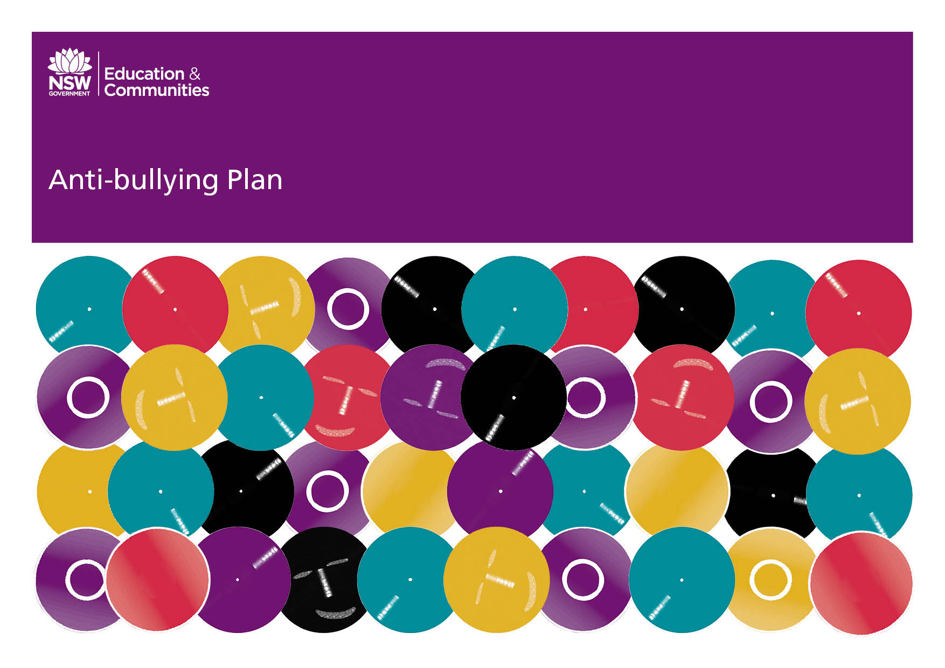

The Meadows Public School

Our School Anti-Bullying Plan
Our school Anti-Bullying plan outlines the processes for preventing and responding to student bullying in our school and reflects the Bullying: Preventing and Responding to Student Bullying in Schools Policy of the New South Wales Department of Education and Communities.
The Meadows Public School supports a prevention and early intervention approach in relation to bullying. We recognise that the best outcomes are achieved by school communities working together to help prevent bullying occurring. Our school has collaborated with staff, students and the parent community to develop protection, prevention, early intervention and response strategies for bullying.

The Meadows Public School’s Statement of Purpose:
“A vibrant and caring learning community.”
We believe:
- our school community should feel safe, secure and happy in the school environment;
- in providing opportunities for students to achieve success;
- that a supportive school community leads to improvement and achievement; and
- in empowering students to face a challenging future.

Any form of teasing and bullying by any member of the school community is not tolerated at The Meadows Public School.

Protection
Bullying
Bullying is repeated verbal, physical, social or psychological behaviour that is harmful and involves the misuse of power by an individual or group towards one or more persons. Cyberbullying is defined as the use of information and communication technologies to support repeated and deliberate hostile behaviour intended to harm others.
Bullying can involve humiliation, domination, intimidation, victimisation and all forms of harassment including that based on sex, race, disability, homosexuality or transgender. Bullying of any form can have long term effects on those involved including bystanders.
Conflict or fights between equals or single incidents are not defined as bullying.
Bullying:
- devalues, isolates and frightens.
- affects an individual’s ability to achieve
- has long-term effects on those engaging in bullying behaviour, those who are subjects of bullying behaviour and the onlookers or bystanders.

Bullying behaviour can be:
- verbal eg name calling, teasing, abuse, putdowns, sarcasm, insults, threats
- physical eg hitting, punching, kicking, scratching, tripping, spitting
- social eg ignoring, excluding, ostracising, alienating, making inappropriate gestures
- psychological eg spreading rumours, dirty looks, hiding or damaging possessions, malicious SMS and email messages, inappropriate use of camera phones (cyberbullying).
School staff have a responsibility to:
- respect and support students
- model and promote appropriate behaviour
- have knowledge of school and departmental policies relating to bullying behaviour
- conduct themselves in a professional manner and treat students and adults with care and respect in accordance with the DEC Code of Conduct
- respond in a timely manner to incidents of bullying according to the school’s Anti-bullying Plan
- contact the Police and the School Safety and Response Unit where incidents of cyberbullying include possible criminal behaviour.

In addition, teachers have a responsibility to:
- provide curriculum and pedagogy that supports students to develop an understanding of bullying and its impact on individuals and the broader community
- ensure that teaching and learning activities reflect equity and promote fairness in respect of gender, race, religion and age
- ensure that children are taught aspects of protective behaviours as part of the schools Child Protection policy
- implement a sustained curriculum approach to address the appropriate use of technology (Digital Citizenship).
Students have a responsibility to:
- behave appropriately, respecting individual differences and diversity
- behave as responsible digital citizens
- follow the school Anti-bullying Plan
- behave as responsible bystanders
- report incidents of bullying according to the school Anti-bullying Plan.
Parents and caregivers have a responsibility to:
- support their children to become responsible citizens and to develop responsible online behaviour
- be aware of the school Anti-bullying Plan and assist their children in understanding bullying behaviour
- support their children in developing positive responses to incidents of bullying consistent with the school Anti-bullying Plan
- report incidents of school related bullying behaviour to the school
- work collaboratively with the school to resolve incidents of bullying when they occur.

All members of the school community have a responsibility to:
  - model and promote positive relationships that respect and accept individual differences and diversity within the school community
  - support the school’s Anti-bullying Plan through words and actions
  - work collaboratively with the school to resolve incidents of bullying when they occur
  - report cases of bullying or discrimination

The school’s Anti-bullying Plan sets out the processes for preventing and responding to student bullying. The school has a range of policies and practices, including welfare and discipline policies that apply to student behaviour generally.
Prevention
Anti-bullying programs are implemented at the beginning of each year, and revisited as needed, to reinforce the school’s Anti-bullying prevention plan. Staff review and evaluate these programs annually. Anti-bullying messages are embedded across the curriculum.
Early Intervention
The school develops and implements early intervention support strategies for students who are identified by the school as being at risk of developing long-term difficulties with social relationships, such as the Get On Track In Time (GOT-IT) program.

Early intervention support is provided for those students who are identified at or after enrolment as having experienced bullying or engaged in bullying behaviour by referral to the school’s Learning Support Team and with the assistance of the School Counsellor.

The school implements Bystander Training as part of the Anti-Bullying program. This is a proactive strategy that trains bystander students to behave in a supportive way to students who are being bullied, to intervene where feasible or to report the incident to a teacher.

Buddy systems, such as the Better Buddies program and Buddy Classes, are implemented to promote friendship and support between older and younger peers through regular collaboration between classes.

Response
The school has a range of strategies in responding to incidents of bullying, such as:
- empowering the whole school community to recognise and respond appropriately to bullying, harassment and victimisation and behave as responsible bystanders
- developing and publicising clear procedures for reporting incidents of bullying to the school
- responding to incidents of bullying that have been reported to the school quickly and effectively
- matching a planned combination of interventions to the particular incident of bullying
- providing support to any student who has been affected by, engaged in or witnessed bullying behaviour
- providing regular updates, within the bounds of privacy legislation, to parents or caregivers about the management of the incidents
- identifying patterns of bullying behaviour and responding to such patterns
- reporting incidents involving assaults, threats, intimidation or harassment to the police
- contacting the Child Wellbeing Unit or Community Services where appropriate
- promoting and publicising this Anti-bullying Plan and making it widely available to the school community on the school’s website
- monitoring and evaluating the effectiveness of the Plan
- reporting annually to the school community on the effectiveness of the Plan.
- reviewing this Anti-bullying Plan with the school community annually
The school provides specific teaching programs to assist students to respond to incidents of bullying, such as TELL (Talk about it to a teacher, Listen…..) and has trained staff, including an Anti-Racism Contact Officer (ARCO) to manage such incidents.

Additional Information
Kids Helpline 1800 555 555

Principal’s comment
The Meadows Public School continually strives to be proactive in our approach to build a happy, safe and supportive school community which is free from all forms of bullying.

This plan has been developed by:
Lisa Littlejohn (Principal)
Renai Diamond (Assistant Principal)
Patricia Meli (Teacher)
Irene Linney (Teacher)
Leah Mizzi (Aboriginal Education Officer)
Chanel Glover (Parent)

School contact information
The Meadows Public School
Fuller St, Seven Hills 2147
Ph: 96313737
Fax: 98963281
Themeadows-p.schools@det.nsw.edu.au
Web: www.themeadows-p.schools.nsw.edu.au

